**AUTHOR PORTFOLIO**

**MARGARET ATWOOD**

**OUTPUT**

**HEADER**



**FOOTER**



**HOME PAGE**

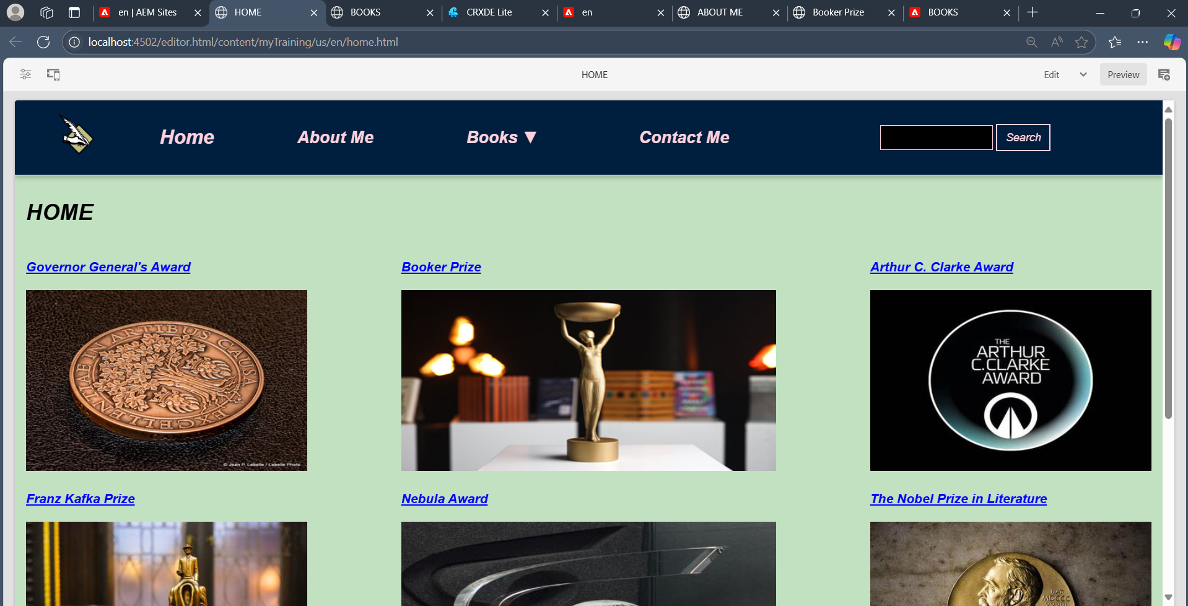

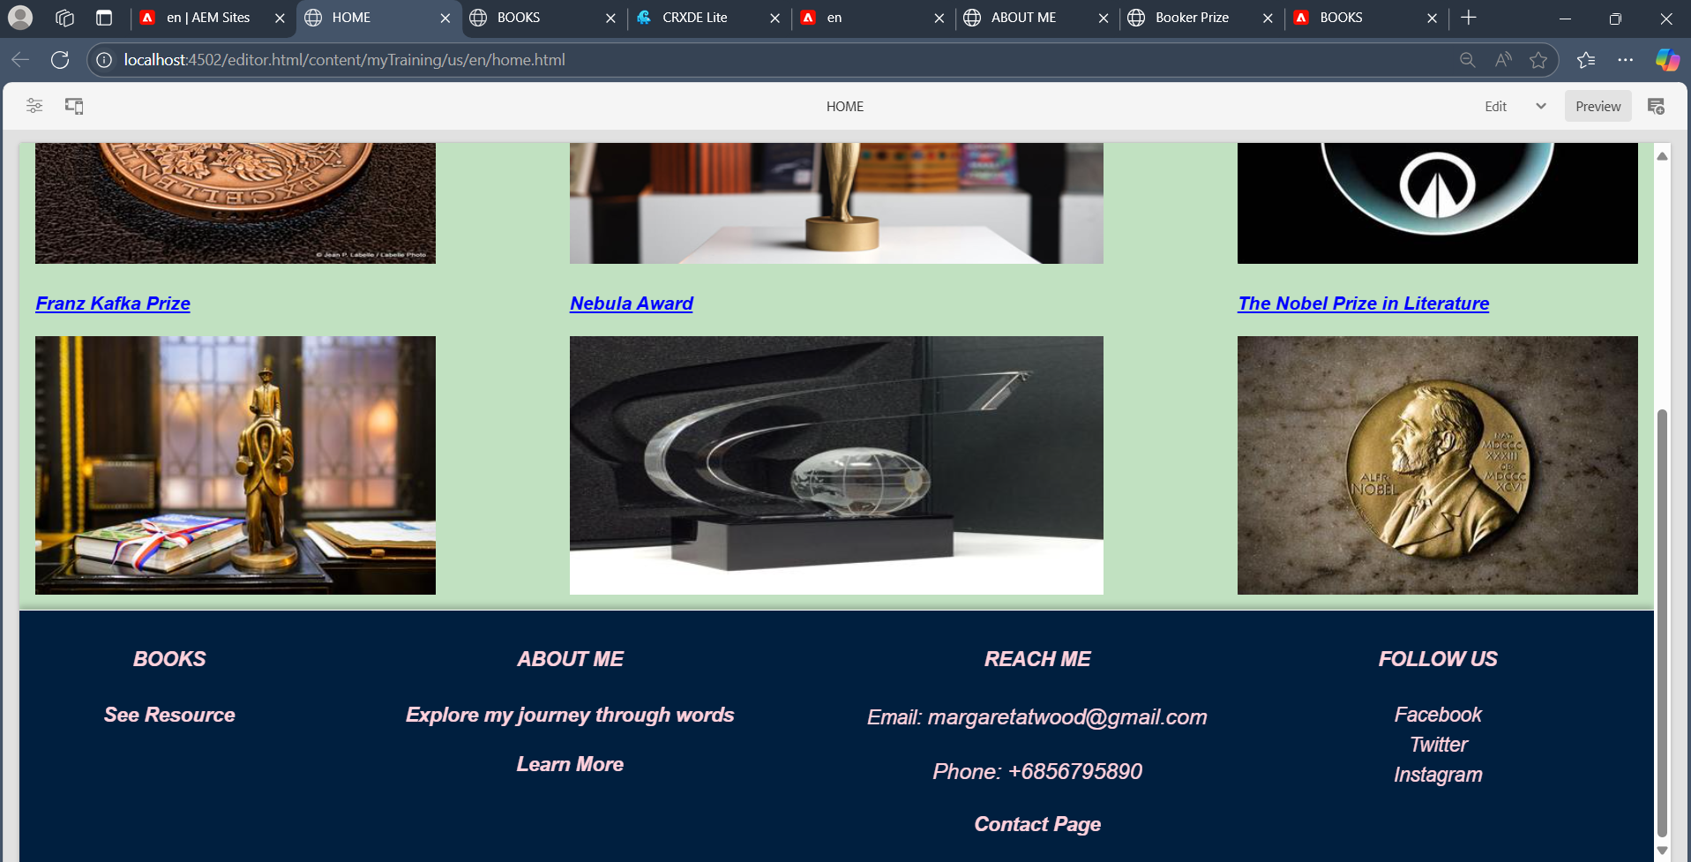

**ABOUT ME PAGE**

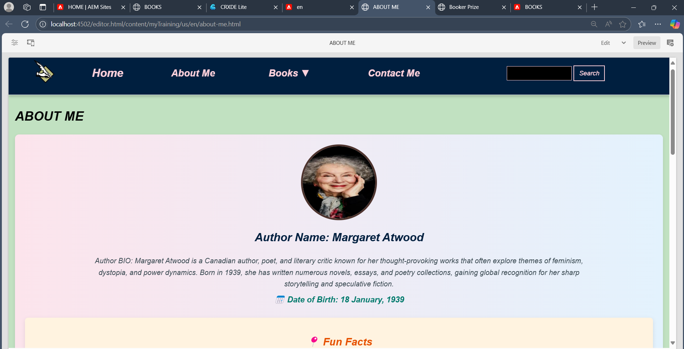

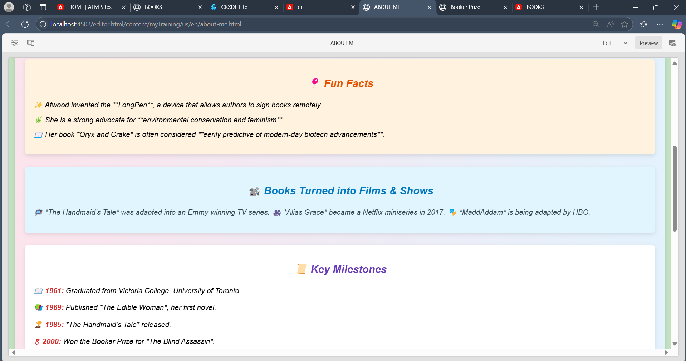

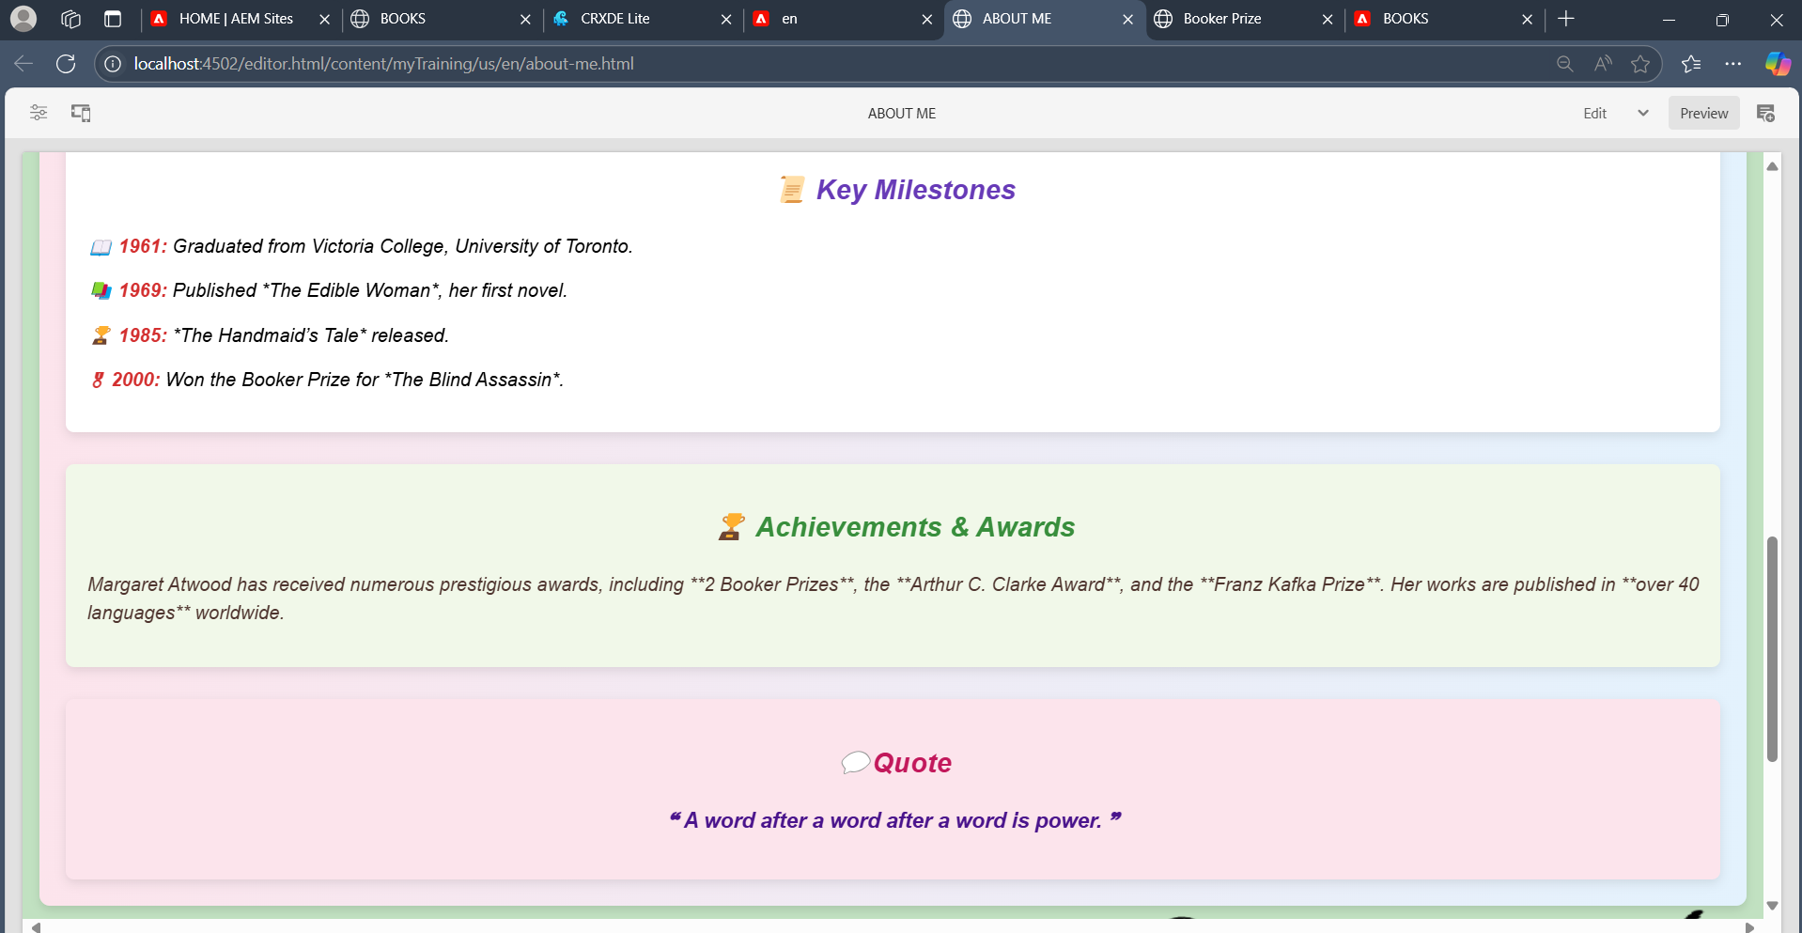

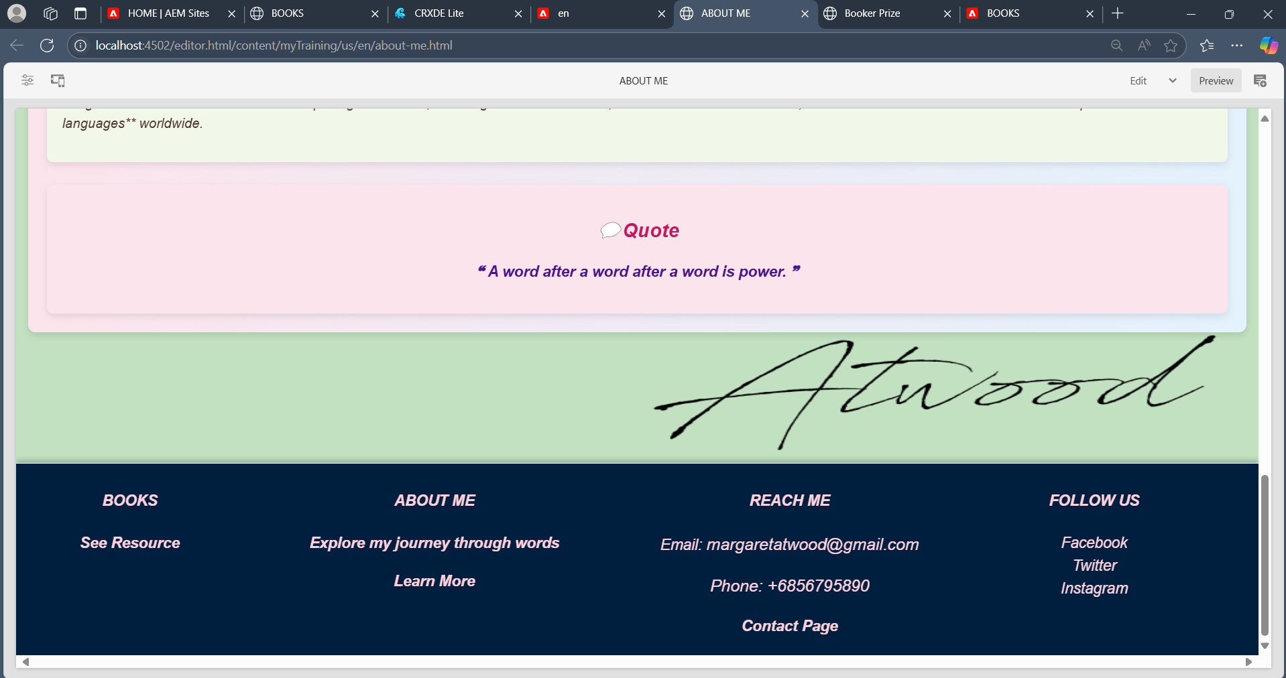

**CONTACT ME PAGE**

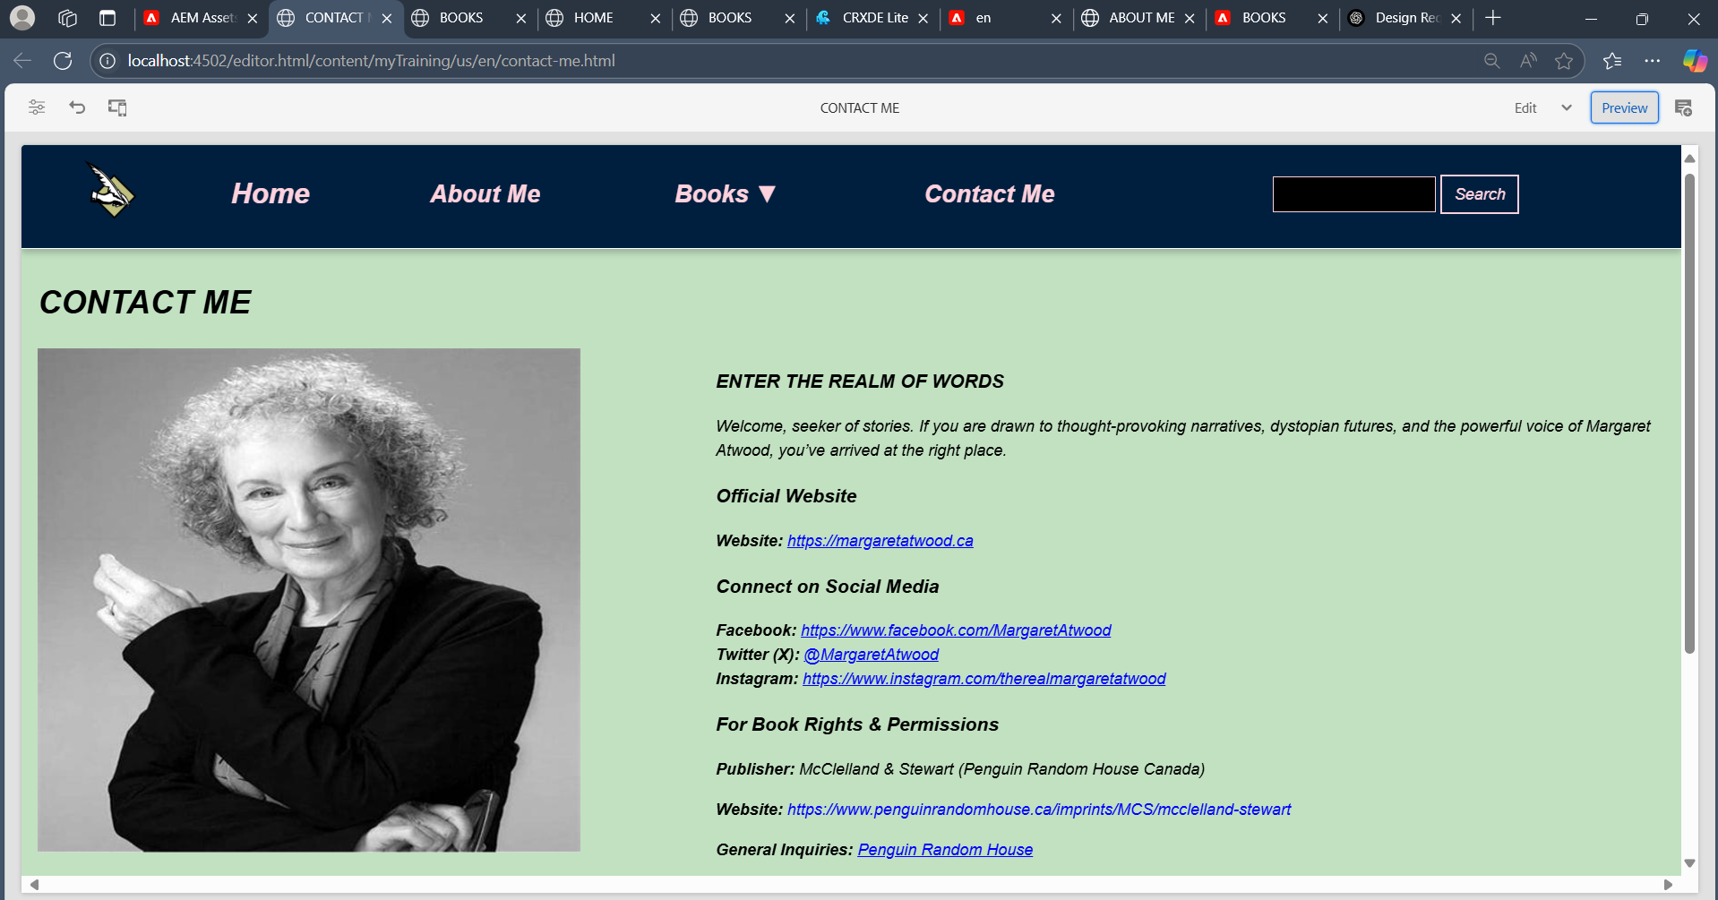

**BOOKS PAGE**

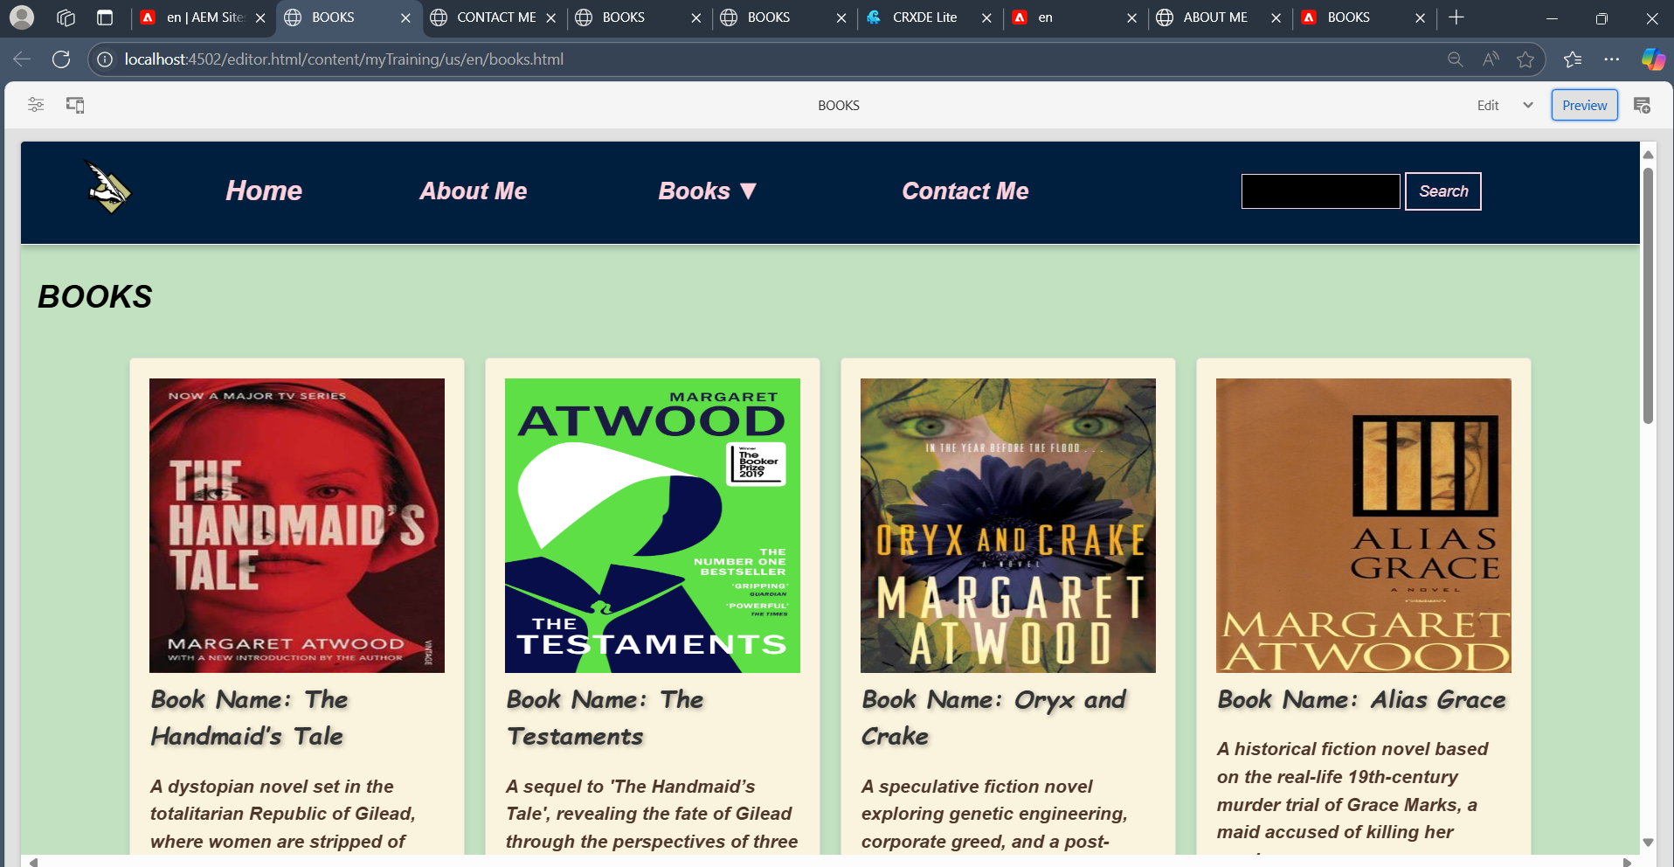

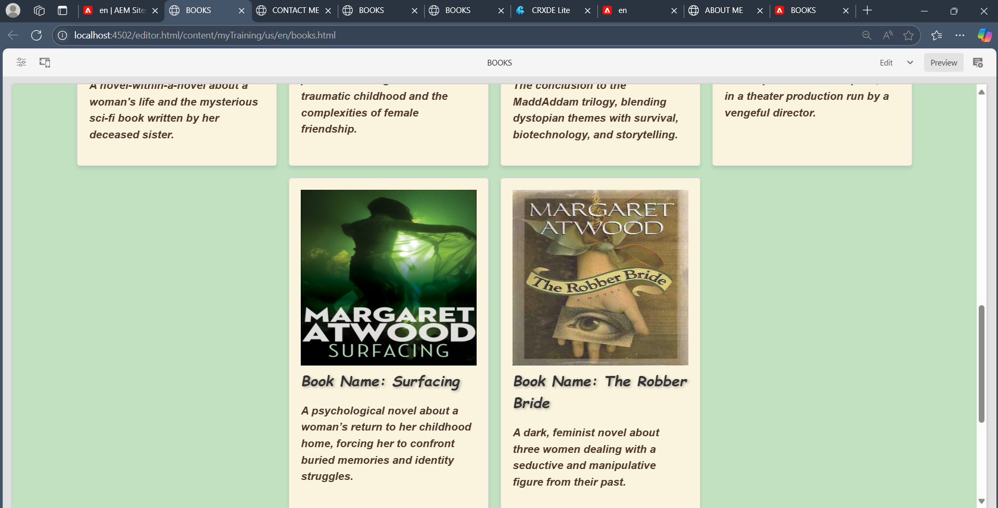

**AWARD PAGE**

* Booker Prize

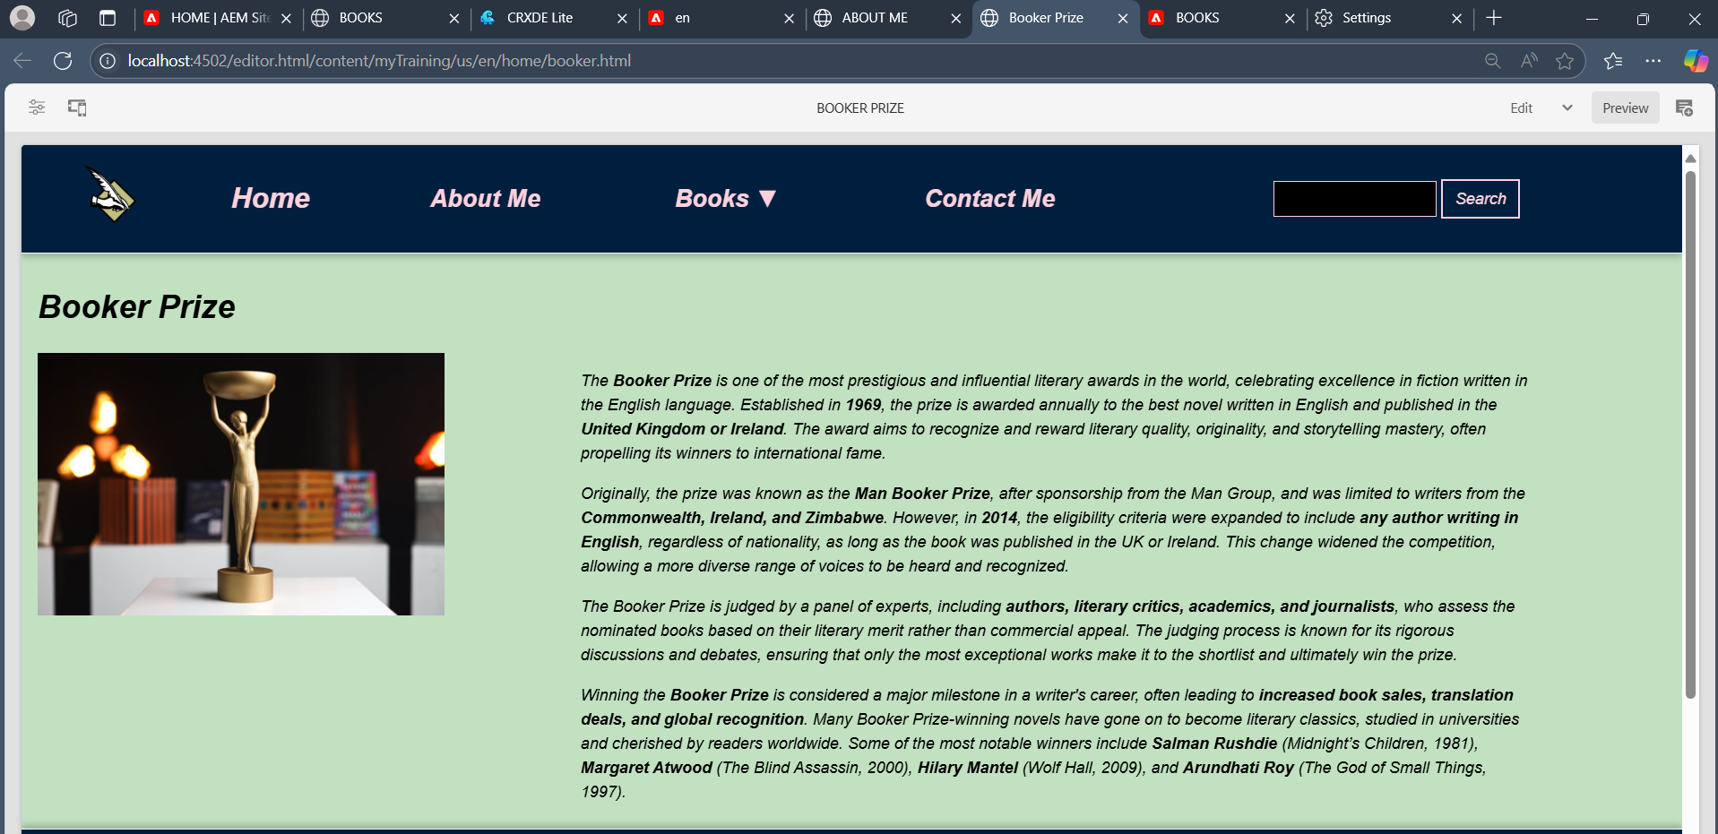

* The Nobel Prize in Literature

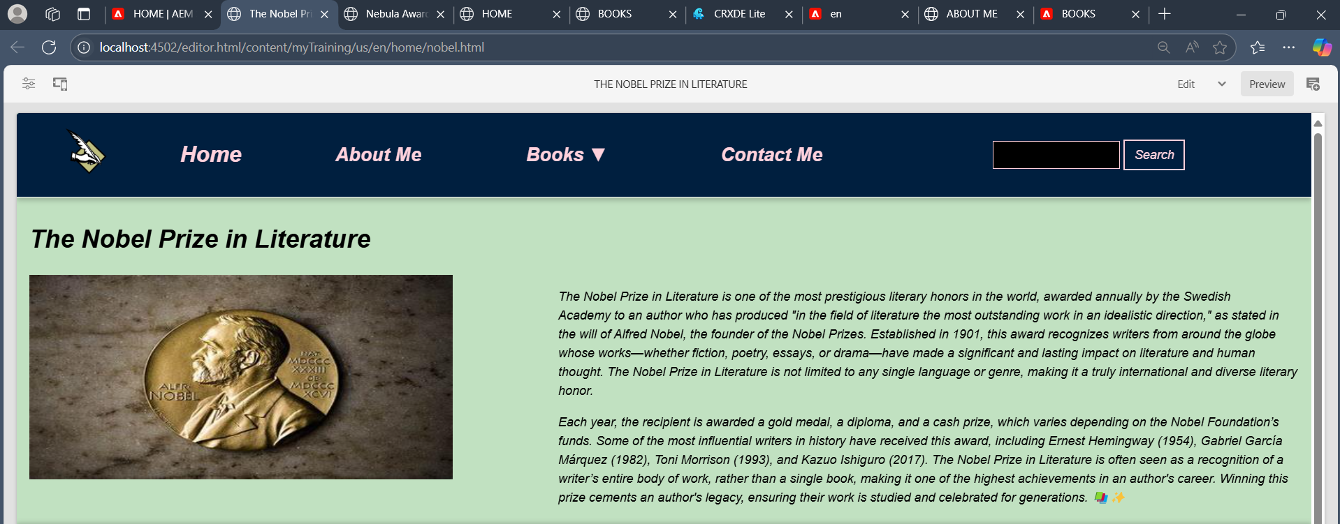

* Governor General’s Award for fiction

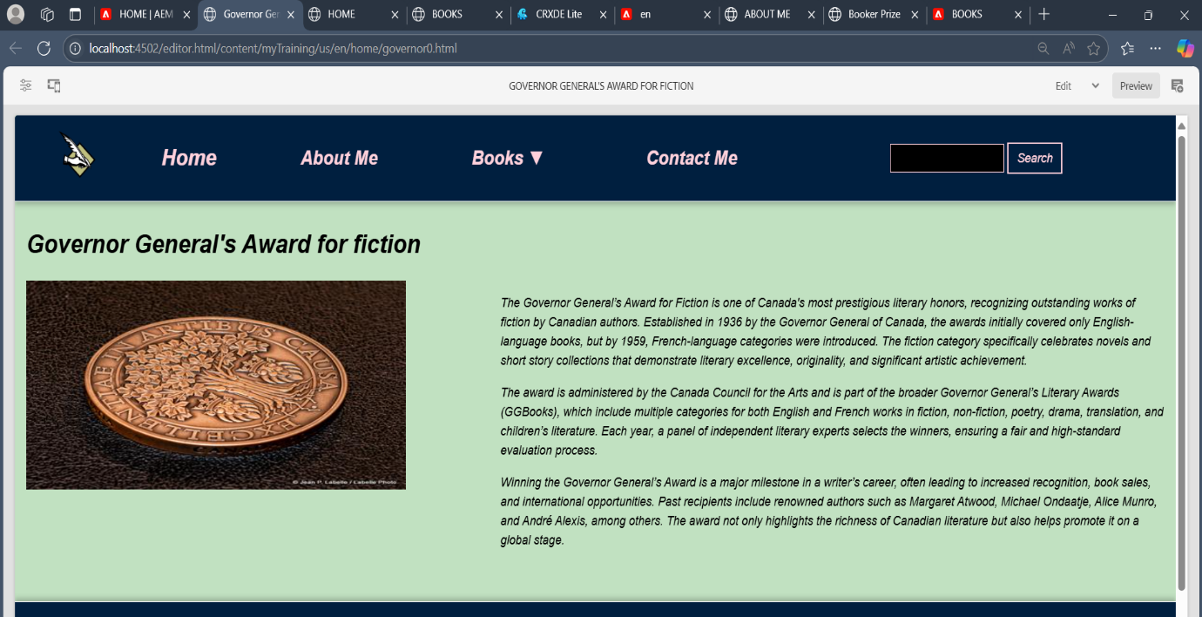

**AUTHOR WEBSITE**

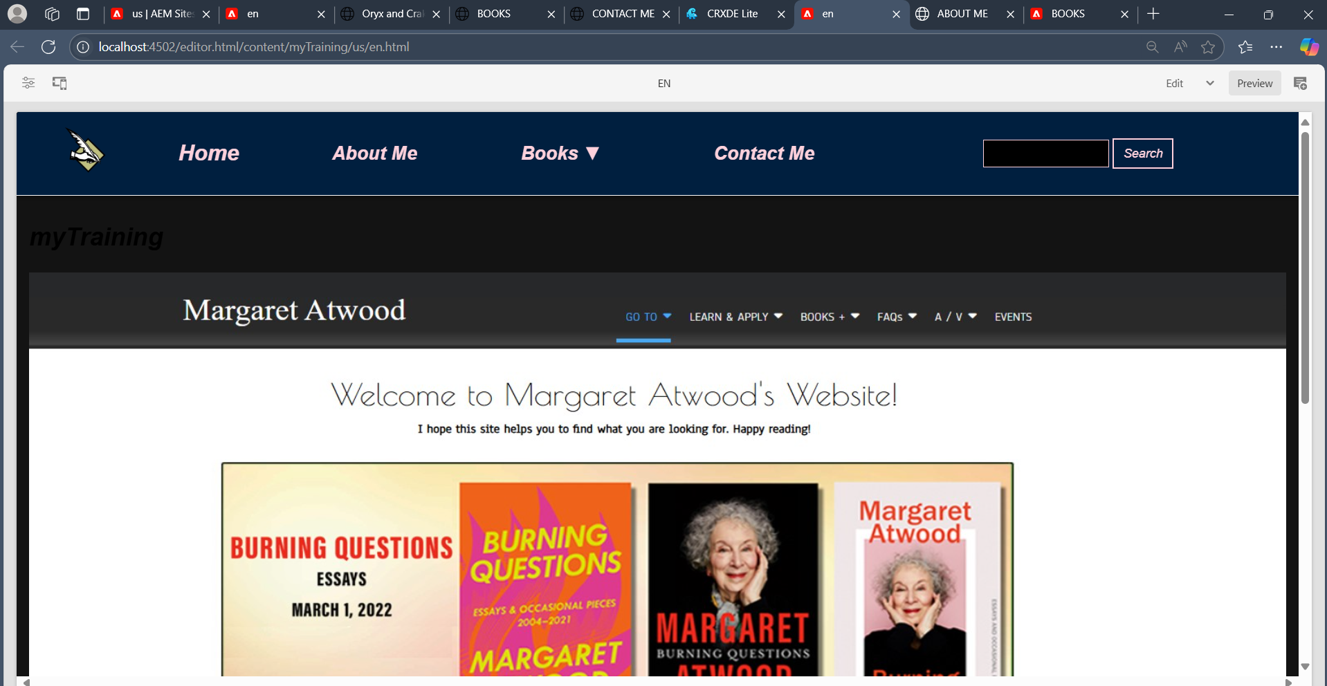

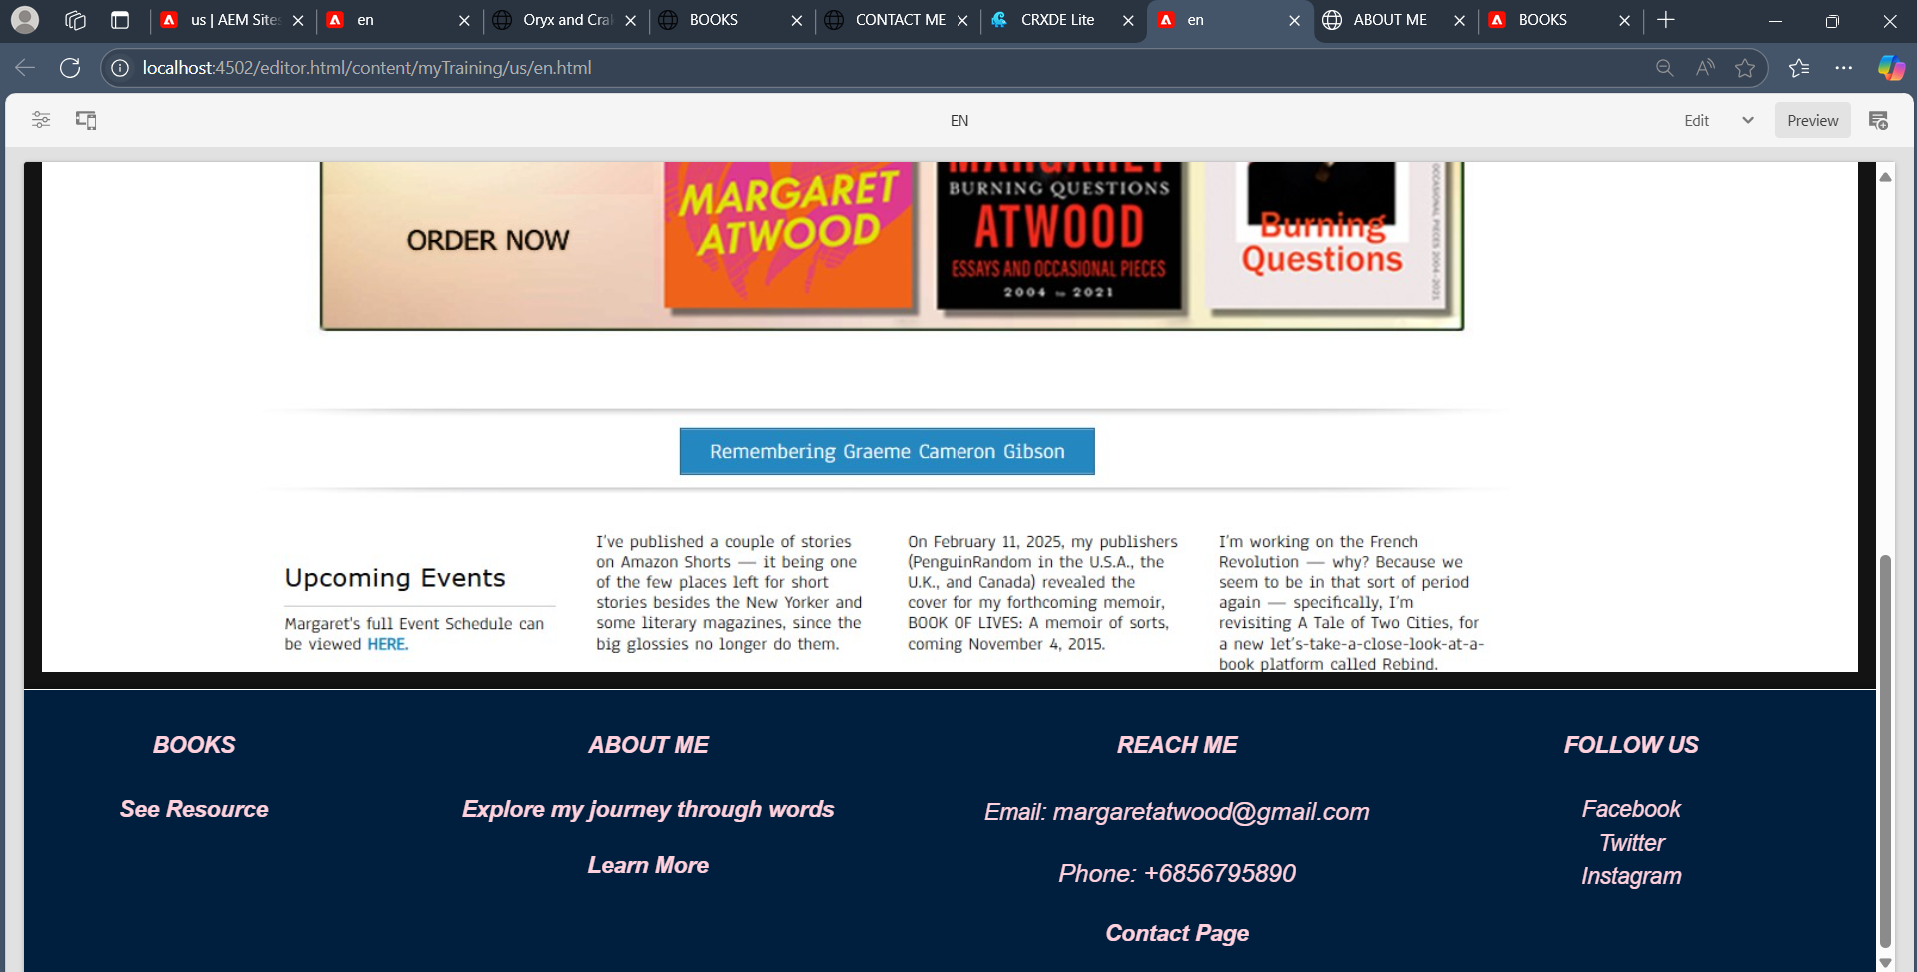

**Functions & Descriptions**

* **Header & Footer Navigation – Clicking links in the header (Home, About Me, Books, Contact Me) and footer (See Resource, Learn More, Follow Us) navigates to the respective pages.**

1. **In header, when I hit Contact Me, it navigates to that specific page**

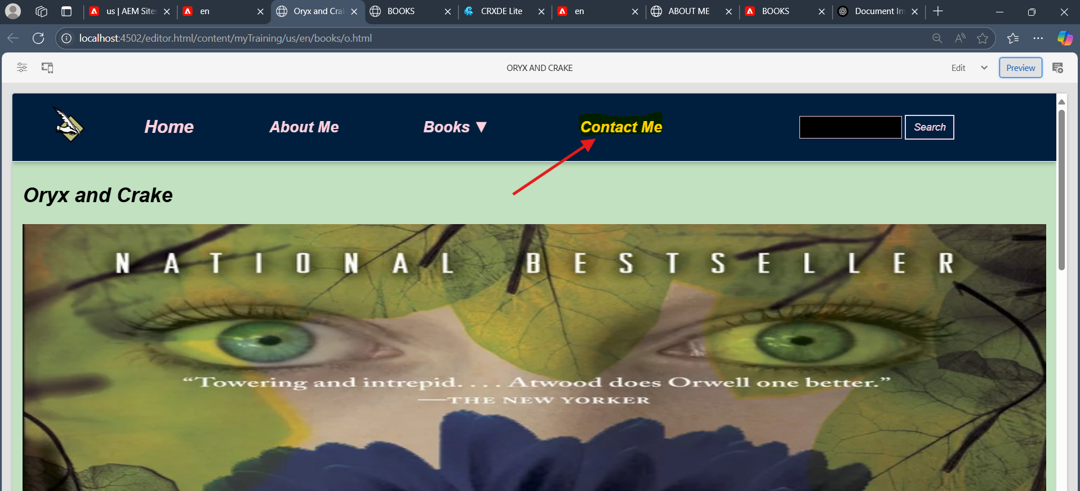

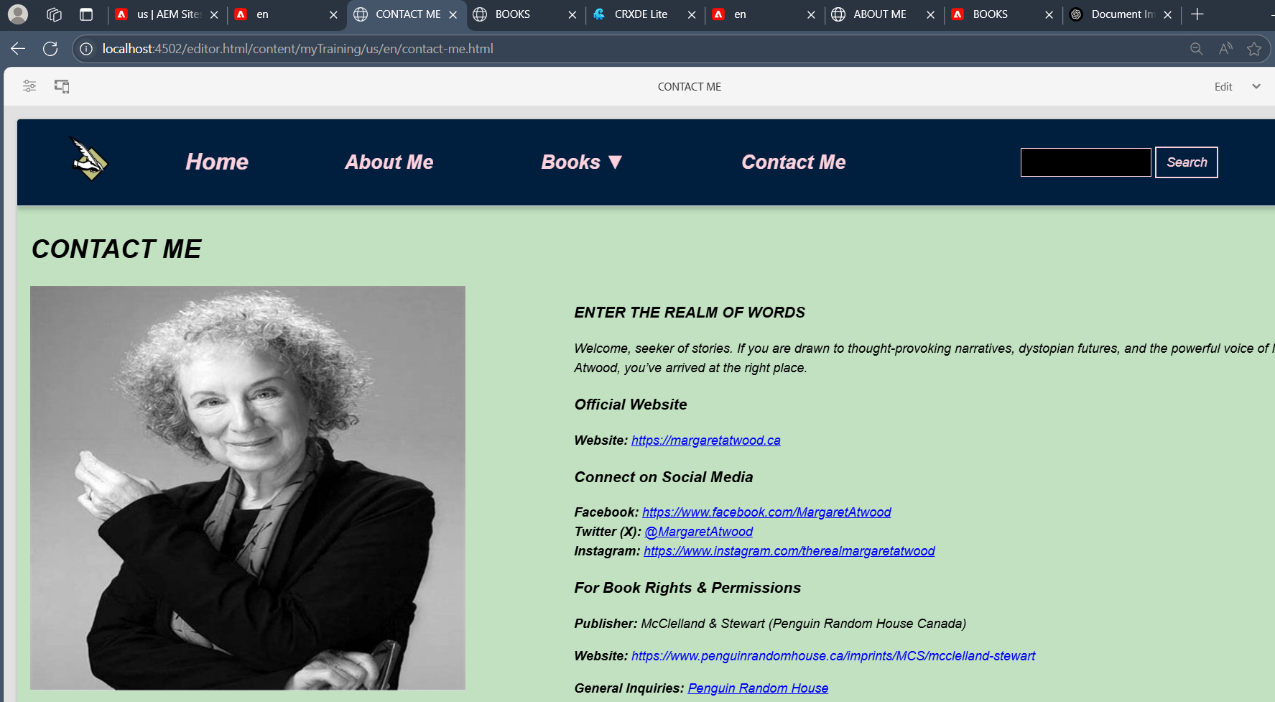

**2.In footer,when I click any social media links (facebook,twitter,instagram),it moves to the facebook page**

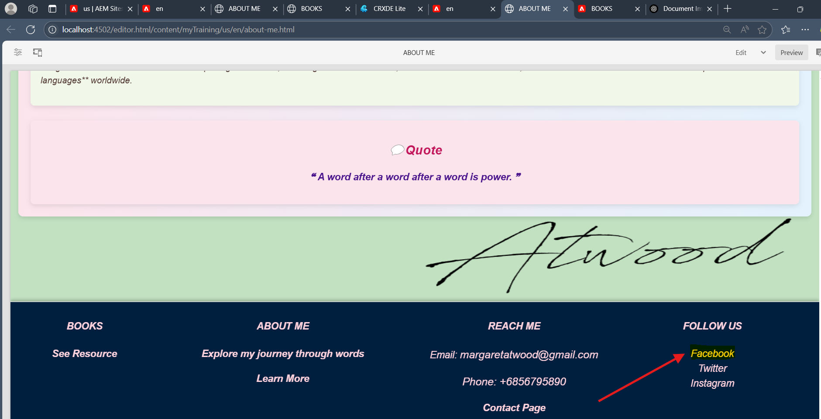

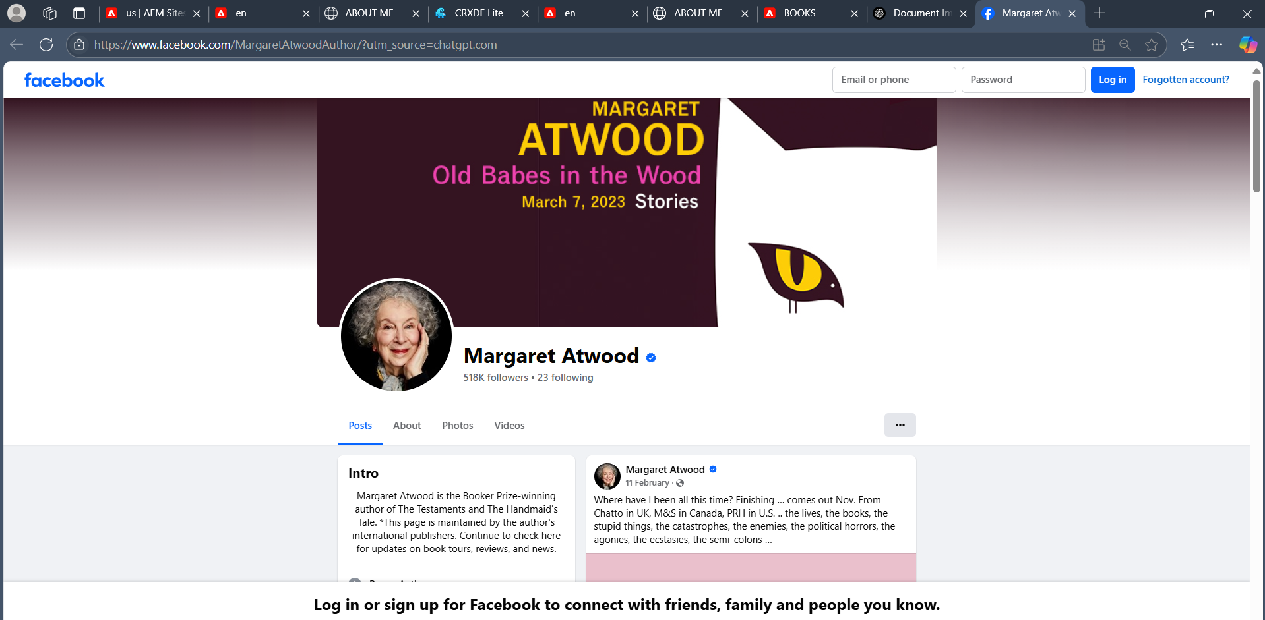

* **Dropdown Menu** – Allows users to select a book from the menu and navigate directly to its detailed page.

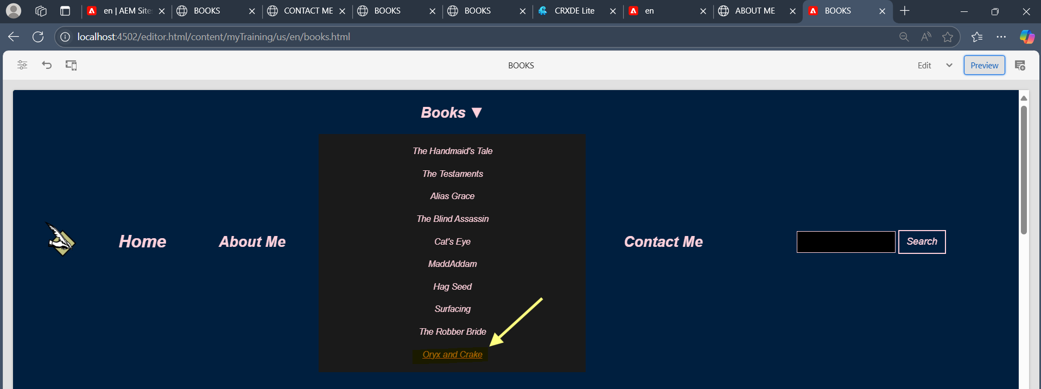

**When I click Oryx and Crake, it navigates to that specific page**

**Oryx and Crake Page:**

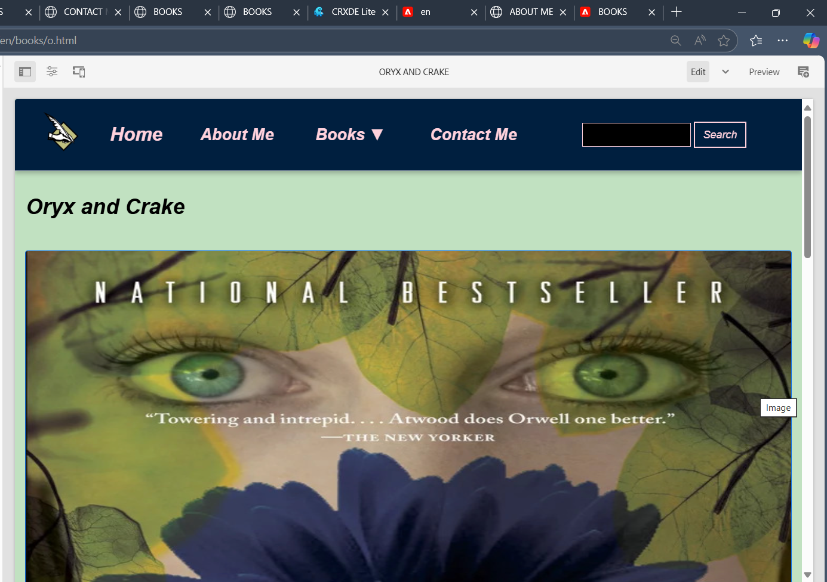

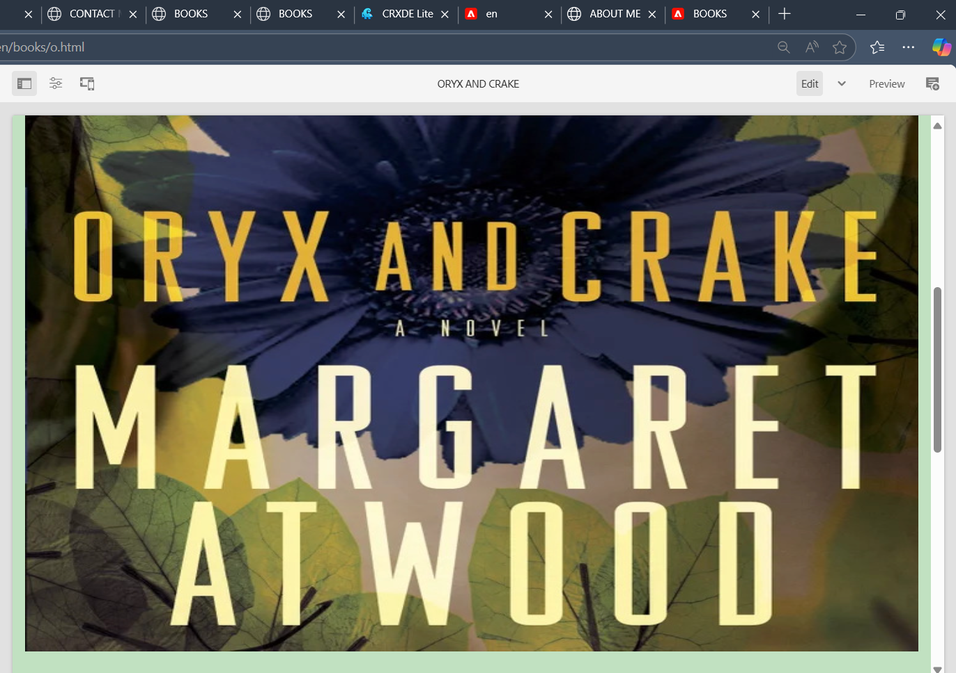

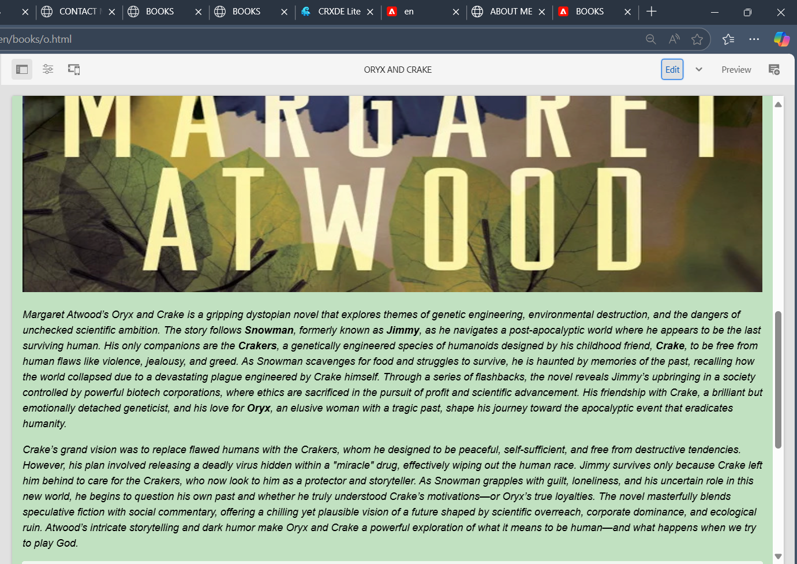

* **Search Feature** – Allows users to search for books, displaying matching results dynamically.

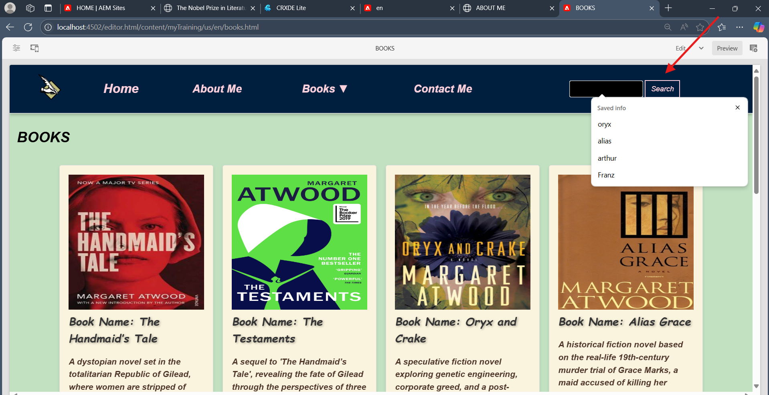

* **API Integration** – Fetches book data from a JSON file or third-party API and displays it dynamically on the Books Page.



* **Load More Button** – Fetches and displays additional books dynamically when clicked on the ‘load more’

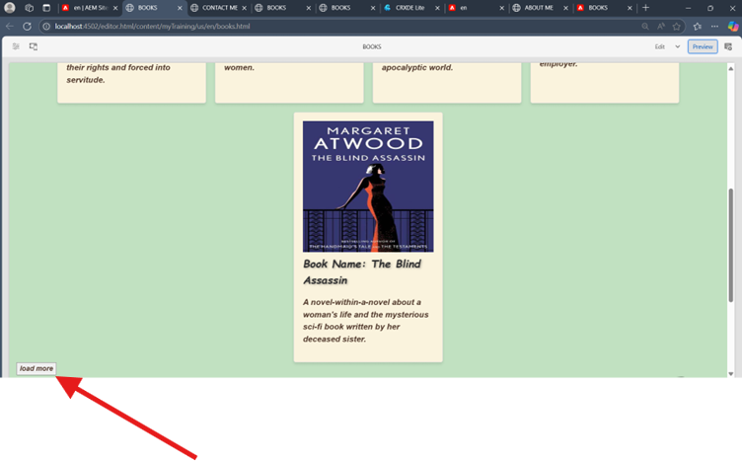

**When we click on “load more”, it loads more cards**

